**CCT College Dublin**

**Assessment Cover Page**

|  |  |
| --- | --- |
| **Module Title:** | Higher Diploma Data Analytics for Business   * Data Preparation & Visualisation * Statistical Techniques for Data Analytics * Machine Learning |
| **Assessment Title:** | Individual / Practical |
| **Lecturer Name:** | Dr. Muhammad Iqbal  David McQuaid  Marina Soledad Iantorno |
| **Student Full Name:** | Miroslava Slavikova |
| **Student Number:** | sba22382 |
| **Assessment Due Date:** | 05 Jan 2024 |
| **Date of Submission:** | 02 Jan 2024 |

**Declaration**

|  |
| --- |
| By submitting this assessment, I confirm that I have read the CCT policy on Academic Misconduct and understand the implications of submitting work that is not my own or does not appropriately reference material taken from a third party or other source. I declare it to be my own work and that all material from third parties has been appropriately referenced. I further confirm that this work has not previously been submitted for assessment by myself or someone else in CCT College Dublin or any other higher education institution. |

Attrition – title……

**Subject area:**

Table of Contents

**Introduction3**

**Business Analysis and Project Plan3**

**Machine Learning Models3**

**Libraries 4**

**Dataset and Data Understanding4**

**Data Preparation4**

**Data Visualization5**

**Hotel Revenue Management7**

**Analysis of Results14**

**Future recommendations** 14

**Challenges15**

**Milestones**15

**Conclusion15**

**GitHub link16**

**Timeline link16**

**Bibliography & References16**

**Introduction**

**Business Analysis and Project Plan**

**Machine Learning Models**

I have used three different supervised machine learning models:

* Decision Tree with accuracy score of
* KNN with accuracy score of
* Logistic Regression with accuracy score of

The results provided reasonable values, albeit not outstanding. Therefore, I have tried to perform PCA that not only compresses data, but aims to improve the accuracy score. Running the KNN model thereafter improved the accuracy score to

**Libraries**

I have downloaded all the necessary libraries, panda for data manipulation and analysis library, matplotlib.pyplot and seaborn for data visualisation, numpy for numerical computing, sklearn libraries for future scaling for ML models, PCA, encoding, training and testing sets, linear regression model for predictive modelling. I’ve also included a Folium, very useful Python Library used for visualizing geospatial data. Libraries have been imported and assigned the abbreviated formats. The abbreviated format makes recalling and use of these libraries more efficient. Lastly, I have uploaded a

**Dataset and Data Understanding**

**Data Preparation**

Descibe

Handling missing values

Numeric with Mean and categorical with Mode.

Mean is for numerical values (mean of each column

Mode for categorical (cannot do average)

**Data Visualisation**

performed several visualizations to review the data in order to have better understanding of the dataset.

We have no missing values now, 2 heatmaps to compare

Describe – we display statistical values to identify outliers

Correlations shows us relationships between variables and how they are correlated.

this is library that helps to perform EDA more effecttively source:

REF: <https://pypi.org/project/fasteda/>

Checked outliers, that majority employees are 30-40 yo Mean age is 36

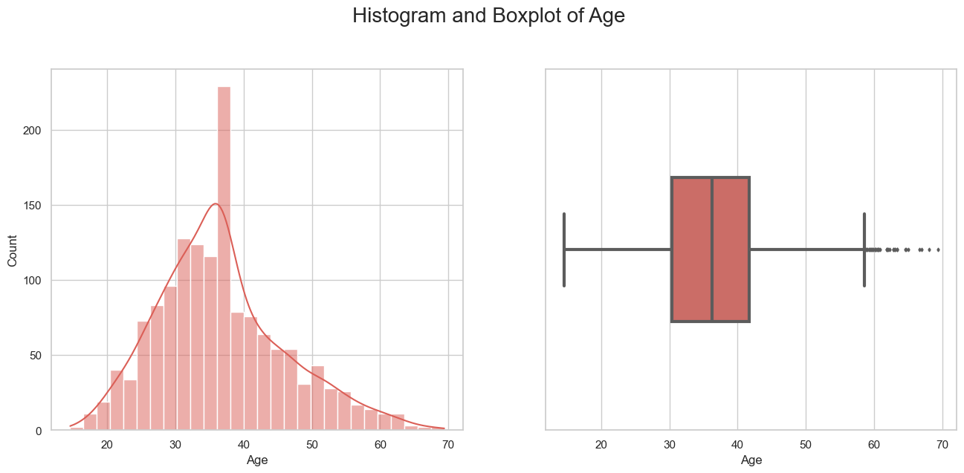

**I found the outlier on the distance from home, but did not drop it because based on our correlation results, I found it there’s no affect the data.**

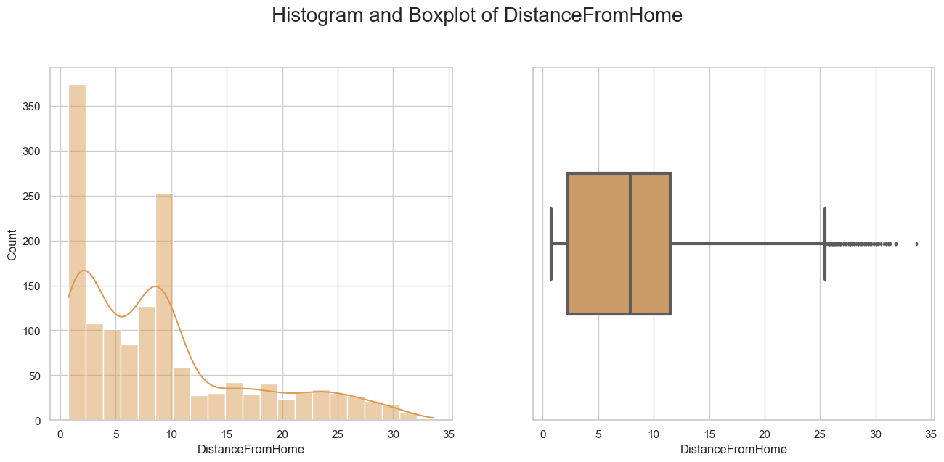

**There’re no outliers in the monthly income variable, the range of monthly income is following:**

MonthlyIncome Mean 6544.72 Median 5495.90 Mode 6544.72

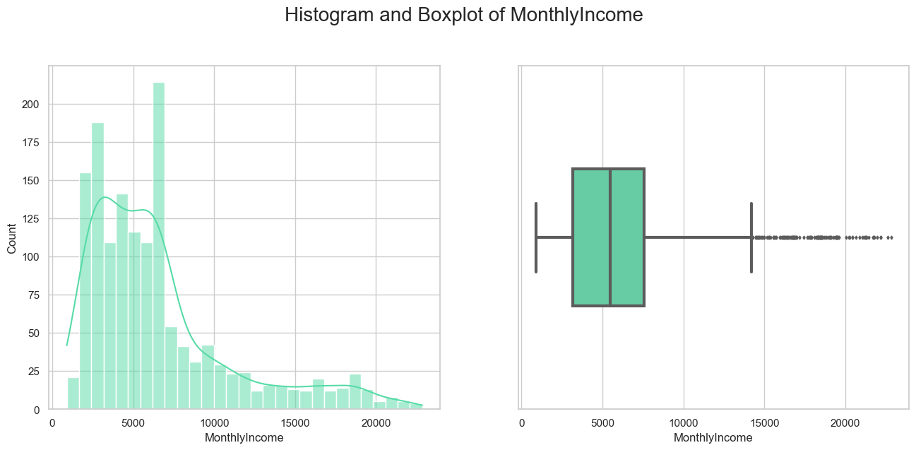

Encoding, Scaling, Feature Engineering

PCA/ KNN

We use StandardScaler to encode categorical values into numerical

Results

LDA/ KNN



We reduced the noise …….

LDA/ Random Forest

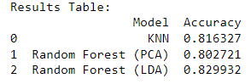

Why is PCA is working better with KNN and LDA with RandomForest …

KNN works on the probabilities

Hypothesis Testing

We use 2 variables to identify how the monthly income affects the attrition and ,..

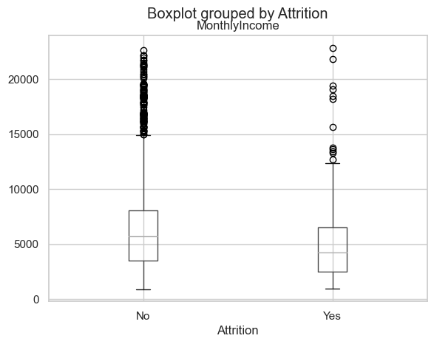

Annova

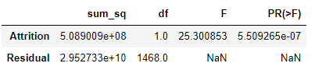

The p-value for 'Attrition' is very low (5.509265e-07), suggesting that there is a significant effect of 'Attrition' on 'MonthlyIncome.'

Year is the company does not affect

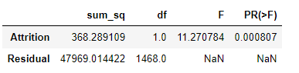

Hypothesis test where

Dep. Variable: MonthlyIncome

Anova table where obtain good p-values, which is higher than 0.05, anything below BAD

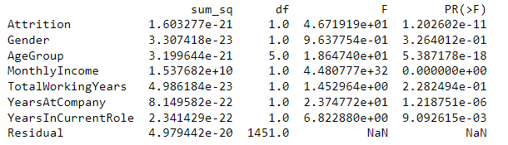

Selection of Hyperparameters

I used the n estimators

'n_estimators': [50, 100, 200]

'max_depth': [None, 10, 20],

Models decided:

Best Hyperparameters: {'max_depth': 10, 'min_samples_leaf': 4, 'min_samples_split': 2, 'n_estimators': 100}

Grid search cv

This means that the model correctly predicted the target variable 'Attrition' for about 80.27% of the instances in the test data. (NOTES: overfitting ……70 is bad, 95 is overfitted) too many variables, with one or 2 is easier

**Machine Learning Model Comparison using Best Hyperparameters**

KNN

Random Forest PCA

Randon Forest LDA

K-fold using split 10 (least time to run and most accurate)

, 20, 30 (30 will take more optimization)

**Data Preparation**

● Characterisation of the data set: size; number of attributes; has/does not have missing values,

number of observations etc.**[0-10]**

● Application of Data preparation/evaluation methods (Cleaning, renaming, etc) and EDA (Exploratory

Data Analysis) visualizations (plural), including a clear and concise explanation of your rationale for

what you are doing with the data and why you are doing it.**[0-20]**

● Apply encoding, scaling and feature engineering as and if required, detailing how and why you used

these techniques and the rationale for your decisions.**[0-30]**

● Explore the possibility of using dimensional reduction on the dataset. Employ both LDA (Linear

Discriminant Analysis) and PCA (Principal Component Analysis) and compare the separation of

classes through visualization. Explain the difference between both techniques in your own words

and discuss in detail how your results may affect your analysis of classifying or clustering the normalas compared to anomalous biddings.**[0-40]**

**Statistical Techniques:**

● Use descriptive statistical analyses to explore and evaluate the data set, including measures of

central tendency and dispersion and frequency distributions. Correlation matrices are also

accepted. Provide a summary of your findings. (0-30 marks)

● Formulate and test hypotheses within a business context using appropriate statistical techniques

like t-tests or ANOVA to identify significant relationships between variables. Provide a summary of

your findings. Use at least two statistical tests. (0-40 marks)

● Use a Jupyter notebook to produce result sets from the provided dataset, such as scatter plots or

regression models. Provide a summary of your findings. (0-10 marks)

● Write the results of the analysis of your findings to stakeholders using clear and concise

explanations, visualisations, and appropriate statistical terminology. (0-20 marks)

**Machine Learning:**

● Provide a conceptual understanding and logical justification based on the reasoning for the specific

choice of machine learning approach (supervised/ Unsupervised) for the provided data set. You can

discuss the pros and cons of both approaches based on your understanding. (0-20 marks)

● Machine Learning models can be used for Prediction, Classification, and Clustering. You can choose

suitable features for the machine learning models based on feature selection methods, such as random

forest or any other method. The selection of hyperparameters for the ML models should be performed

by using hyperparameter tuning, such as GridSearchCV. Obtain the best accuracy using optimal values

of the hyperparameters. (0-30 marks)

● You should train and test the Machine learning models in the case of supervised learning for different

splits (at least 2 splits) and use appropriate metrics for unsupervised learning. Use k-fold (10 or 20 or

30) cross-validation to provide authenticity of the modelling outcomes. (0-30 marks)

● Exhibit a comparison of ML modelling outcomes using a Table or graph visualisation. Identify the

possible similarities and contrast of the Machine Learning modelling outcomes based on chosen metricand discuss their statistical understanding. (0-20 marks)

**Analysis of Results**

**Future Recommendations**

## **Challenges encountered**

I have encountered numerous challenges while working on this dataset. Larger volume of data provides more information for the training and might lead to better performance.

Additionally, I’ve identified a lot of missing vales, and identifying the best performing model with better accuracy score.

Admittedly, the project overall was a challenging task, but generally speaking, I really enjoyed learning and attempting to understand such a complex subject of study as Data Analysis and Machine Learning.

**Milestones**

Researching while working on this project helped me to gain better understanding of visualisation techniques and how to interpret the various graphs and charts, gradually gaining confidence in this subject. I've also developed a better understanding of GitHub, including version control and how to create repositories.

**Conclusion**

**GitHub link:**

**Timeline:**

**References & Bibliography:**

<https://www.sciencedirect.com/science/article/pii/S2352340918315191>

<https://www.kaggle.com/>

https://pypi.org/project/fasteda/

<https://towardsdatascience.com/how-to-clean-your-data-in-python-8f178638b98d>

<https://www.analyticsvidhya.com/blog/2020/06/guide-geospatial-analysis-folium-python/#:~:text=Folium%20is%20a%20Python%20library,library%20for%20plotting%20interactive%20maps>.

<https://realpython.com/>

<https://www.geeksforgeeks.org/>

<https://pandas.pydata.org/>